MATLAB Project :

By: Muhammad Abdullah Nasim

Roll Number : 2019-10-0085

Summary : This is an educational program for people who are new to biology. It will not go into details or use terms such as primers, but will instead introduce the user to the idea of DNA sequencing and base pairing. The program includes three ‘levels’ all of which are accessible by one main graphical user interface.

Usage: The main GUI can opened by typing runme in the command window.

It is advised to proceed in the order: Haemoglobin>Keratin>Some Protein.

Options: After GeneLoader has been loaded, the user is given the options of:

(i)Haemoglobin ( A basic representation )

(ii)Keratin ( Incorrect or Correct )

(iii)Some Protein (User plots bases himself/herself )

(iv)HELP ( Reminder for which base pairs with which base )

Features: Additional Features include:

Notifies the user incase he or she has made an error in completing the base pairs.

During the base pair animations ( figure window ), makes sure that an input is only stored from a click as long as it is within the boundaries of the rectangles.

Message boxes with pauses.

Images plotted within axes in the GUI.

Theory : Put in simpler terms, human growth occurs when cells replicate. To do so, a code must exist within human cells to execute replication. This code is called DNA. Within the nucleus of the cell, DNA is broken up and ‘decrypted’ i.e the bases within the DNA strand are identified. These bases include compounds which are called Adenine(purines), Thymine(pyrimidines), Cytosine(pyrmidines), Guanine(purines). A DNA is a double helical structure which is actually broken up and two separate strands are formed. Each strand has different bases on it. A complimentary strand is made for each strand by pairing the bases on the initial strands with their complimentary bases. The base Adenine always pairs with Thymine and the base Cytosine always pairs with Guanine. This is also shown below:

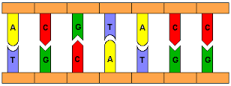 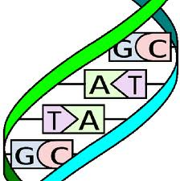

After the base pairing is complete an enzyme checks the pairs and ends replication. This is shown by the animation after the third level.

Structure:

The main program is started by runme, which then opens the main GUI called GeneLoader. This GUI has 4 buttons in it, Haemoglobin, Keratin, Some Protein and HELP.

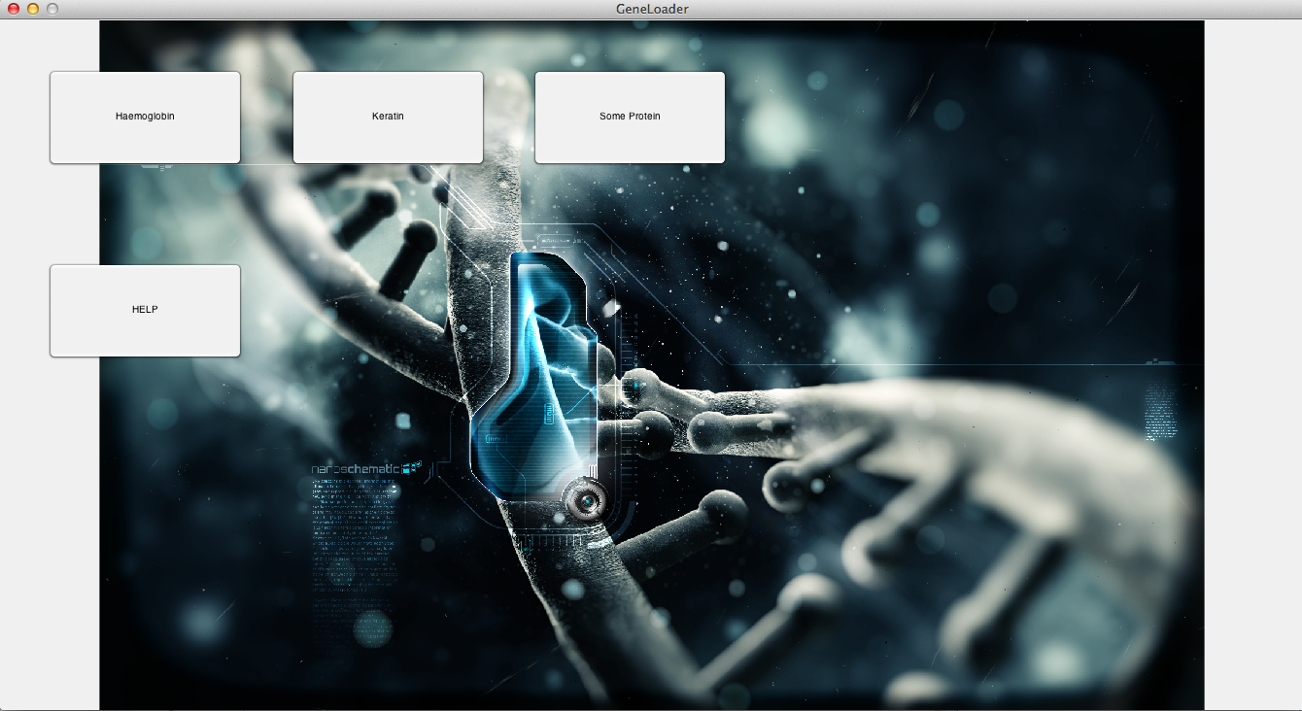

1. After clicking Haemoglobin, a GUI called DNAInteractor opens up. This GUI includes a ‘Plot Haemoglobin’ button which calls on the MakePairVector.m file and accesses the ‘plothaem’ callback to plot 6 shapes in the bottom strand. At the end of this program a pairing button becomes visible which accesses the ‘pair’ callback in DNAInteractor.m. The ‘pair’ callback calls on the plotpair.m file and hence plots all the complimentary base pairs in the top strand. A message box then shows the user what has happened and takes the user back to the main GUI ( GeneLoader ).

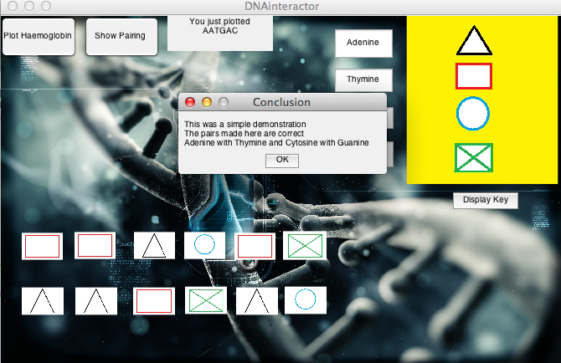

1. After clicking the Keratin, a GUI called KeratinDNAInteractor opens up. The first button which is visible plots the bases according to the code shown in the static text box. This text box calls on the MakePairVector.m file and the KeratinBrokenPairs.m file to plot the shapes in the bottom strand. At the end of this function, the pairing button becomes visible. Upon pressing this a file called PlotIncorrectPair.m is accessed, which then plots a sequence of bases ( which is essentially incorrect ). Two buttons become visible which give the user an option to decide if the base pairs made are correct or incorrect. Upon clicking either of the button a message box is displayed and then the IcnFix callback is accessed. This makes the Fix base pairs button visible and hence the base pairs are corrected. The user is then taken back to the initial GUI ( GeneLoader ).

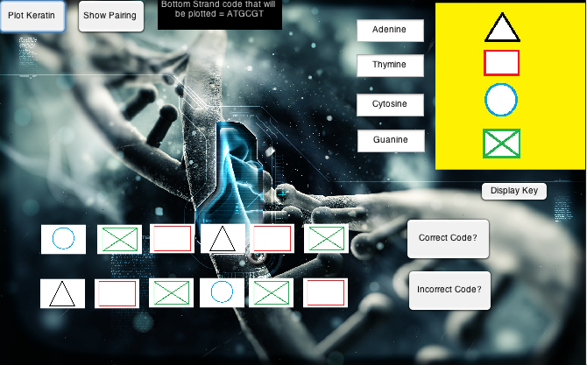

1. After clicking the Some Protein button, a GUI called SomeProtien opens up. Initially a GenerateCode button is seen. This button accesses the RandomTable.m file and generates a random string of code containing 9 characters or 3 codons ( 3 chars=1codon). After this the generated string is plotted when the Plot code button is pressed. This button accesses the callback ‘drawbases’ and calls on the DrawingBases.m file. After this has been completed and the bottom strand has been plotted four buttons become visible. These buttons have the names of the bases and by clicking the buttons the bases are plotted. The functions called upon clicking any button include : guankey,cytokey,adenkey,thymkey and MakingVectorPair.m. After this a continue button is visible which runs the Check file. If the code is correct, an animate.m file is called upon and a figure window opens up in which the user must be able to click on the rectangles and make the enzyme move towards them. The rectangles placed randomly then move towards the bottom pairs and hence the dna strands are complete once the bonds made are shown. Where there are three lines, cytosine is paired with guanine and where there are two lines, adenine has been paired with thymine.

